Packaging Alumni Association Corporate Credit Card Giving Instructions

- Choose GIVE NOW button
- Add to cart “School of Packaging Alumni Giving Fund”
See screen shots for guidance below:

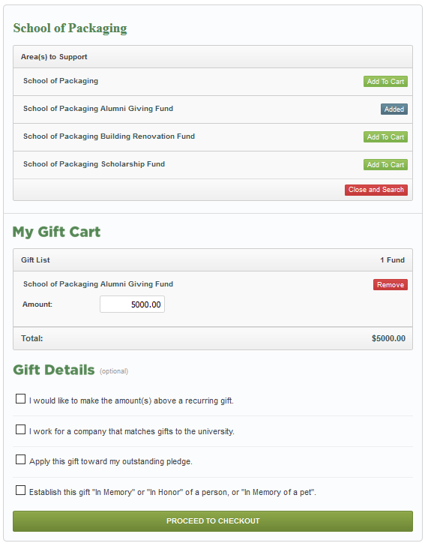
- If you are a returning donor you may try to search for your corporate account, otherwise, skip this step
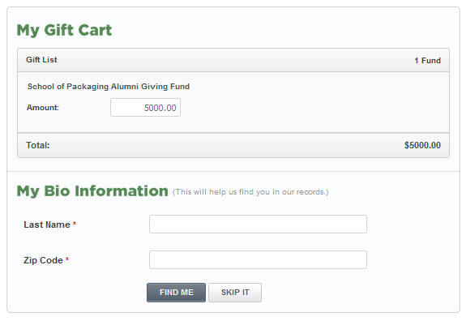
- Use company name and address as the donor information; see
- If the company is paying for it/supposed to get the credit for it, then they should type in the company name in the “My Bio Information” section.
